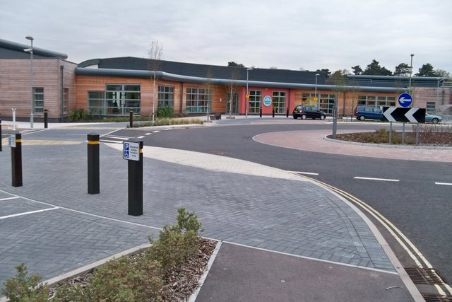
Consultation: Our Vision for Fareham Community Hospital

Contents | Page
About… | 4
How to respond… | 4
Evaluating responses… | 6
How we will use your response… | 6
Want we want to do… | 6
Consultation questions… | 7
Details & consent… | 24

Foreword from
Suella Braverman,
Member of Parliament
for Fareham
Healthcare in Fareham is a priority for me. Shortly after being elected in 2015, I set up Fareham Community Hospital Taskforce to support increased utilisation of the hospital. It brings together senior executives from local health authorities, patient groups and local representatives to discuss health needs and collaboration. Since it was launched, delivering a high quality of care and ensuring the right services are available for patients sits at the heart of what the Taskforce does.
I want patients and practitioners to determine the future direction of healthcare in Fareham and I have launched this consultation as an opportunity for everyone with a stake in FCH to have their say. The consultation is underpinned by three principles, which need to be considered at every stage. Need: are we meeting local demand for services. Deliverability: can we get the services implemented. Sustainability: can we maintain services within current budgets.

- About the consultation
Fareham Community Hospital Taskforce are seeking views on how we propose to change, add, or identify new services, and implement new arrangements, at Fareham Community Hospital. This is in order to ensure appropriate services, which meet the health requirements and needs of our area, are in place. This consultation is about the specific services you, as a stakeholder in healthcare delivery in Fareham, would propose to be put in place. Your guidance and recommendations will be added to a draft report, which will be subject to further consultations at later dates.

- How to respond to this consultation
The closing date for responses to this consultation is 20 June 2018.
You can answer as many of the consultation questions as you like. You do not have to answer all of the questions, unless you wish to do so. Please respond to this consultation in one of two ways:
- Complete the form online and email your response to Joshua.gray@parliament.uk
- Post your response to:
Office of Suella Braverman MP, 14 East Street, Fareham, Hampshire PO16 0BN

- Evaluating responses
To ensure responses are evaluated properly, it is required that we know who is responding to the consultation and in what capacity. The information page is located toward the end of this consultation document. Please note that we may publish all or part of your response unless you tell us (in your answer to the confidentiality question). If you tell us you wish your response to be treated as confidential, we will not include your details in any published list of respondents, although we may quote from your response anonymously.

- How we will use your response
Your response will be used to help us finalise a draft strategy for Fareham Community Hospital for the near and long term. After the consultation ends, we will publish a draft report summarizing responses and identifying trends in what services or usages local healthcare providers and stakeholders wish to see brought to Fareham Community Hospital. A later consultation will take place on the draft report, before the final report is published. Your consultation contributions will directly inform the draft reports.

- What we want to do, our vision:
We are consulting a wide range of stakeholders, practitioners and clinicians involved in the provision of services at Fareham Community Hospital and healthcare in Fareham in broader terms. We are also consulting third party groups working with the hospital and patient groups. Through this process, we will develop a clear set of priorities and identify those services which meet healthcare needs for our area. When proposing news services at FCH, deliverability and working within financial boundaries will be strong considerations. Our aim through this consultation is to identify services which are deliverable and of greatest utility to people in Fareham.

We want Fareham Community Hospital to lead the way for healthcare in Fareham. This means responding to local health need with the right services in a way that is sustainable. Therefore, underpinning the report are three core principles:

- Need – meeting local demand for services in Fareham and serving the community

- Deliverability – ensuring we get the services we need fully implemented and delivered

- Sustainability – maintaining services within current budgets

- Consultation questions
- Accessibility – we want Fareham Community Hospital (FCH) to be accessible to all. With usage set to continue to increase with the additional footfall from same-day services, we want to hear from you on how we can make FCH more accessible.

- Public Health - we want FCH to be a public health hub, with services for those suffering from a range of public health issues.

Exercise classes and clubs led by health professionals have been shown to support the wellbeing of patients diagnosed as clinically depressed, or suffering from anxiety or clinical obesity.

Such a function at FCH could also include strong links to local sports clubs (e.g. bowls) and community groups.

Being mindful of the need for deliverability and cost effectiveness, how do you believe FCH can be utilised as a public health hub and what services should be prioritised?

- Walk-in centre – given the success of the Same-Day-Access-Service which is now available to around 39,000 patients from 3 surgeries, with 8,510 calls having been triaged and 1,864 people receiving face to face consultations, should walk-in services now also be considered? If so, how?

- Supporting senior and elderly patients – Fareham has a significant over 60s and elderly population. The last census revealed that most growth since 2001 has been in the oldest age groups, with the 65 and over's increasing by 21.2%. How can FCH be utilised to meet the growing need to support our ageing population?

- Clinical use of FCH – what clinical services would FCH benefit from?

Some options include:

- Minor operations theatre or treatment room
- Acute chronic illness centre to manage day-to-day chronic illness
- More diagnostics facilities (e.g. CT scan, biopsy facilities, endoscopy)

- Paediatrics – we want paediatrics services that meet the needs of children in Fareham. What services are deliverable or you believe to be of interest to FCH?

- Community engagement – we want FCH to work with local groups and schools.

This would involve local schools being invited to meet doctors and healthcare professionals, as part of their curriculum.

This could cover areas of personal development, mental and physical health, possibly through having weekly lessons at FCH. Other community groups could benefit from public health related sessions.

How do you see FCH engaging with the community and how would you advance community engagement?

- Priority – what do you view as the prevalent health priorities in Fareham, and how do you see FCH’s role in addressing these?

- Priority – we want to hear your thoughts, recommendations and proposals on what services you believe will best serve the people of Fareham and be best utilised at FCH. Or, alternatively, what the major obstacles to progress are. Please provide details below...

- Details & consent
Name
Address
Preference on anonymity

(Do you wish to have your details kept private?) Y/N

